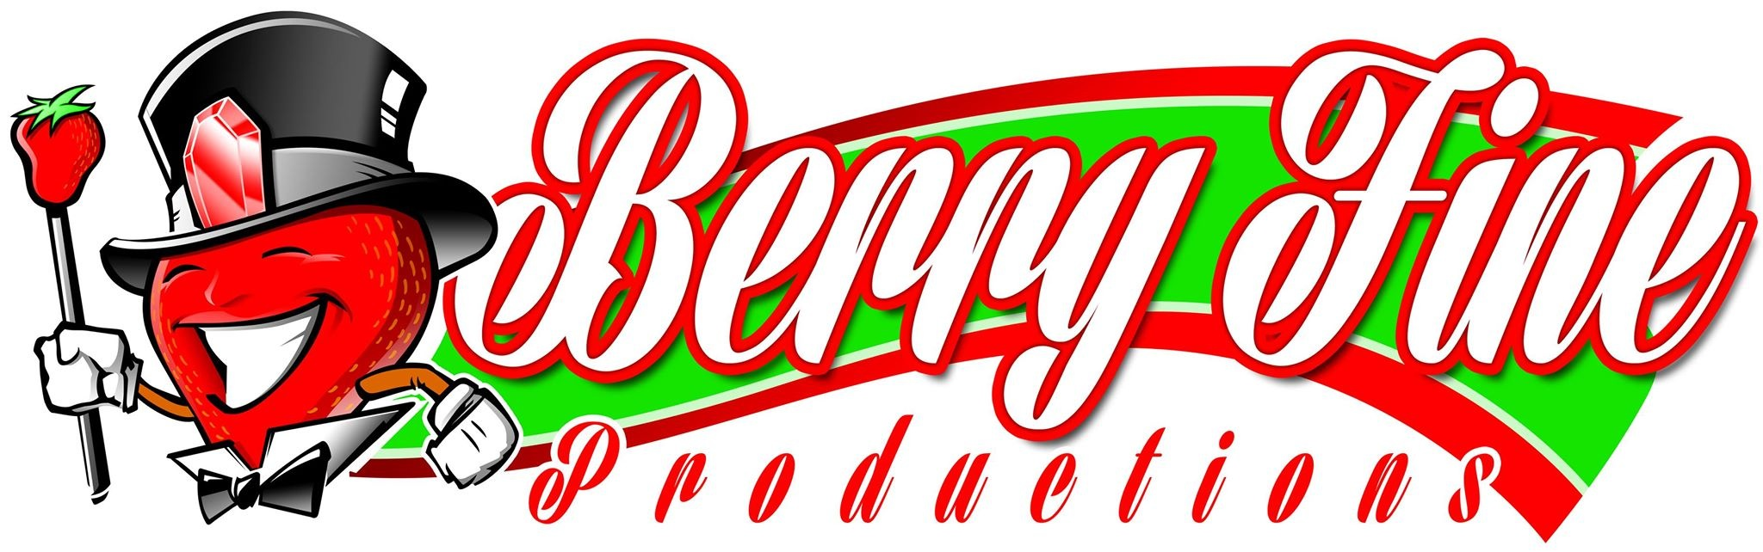

STRAWBERRY PARADE
March 4th, 2024, at 1:00 P.M.
Moves through downtown Plant City to Sammonds Road

Chairperson: Gail Lyons, Berry Fine Productions (813) 967-6366
Applications Available: December 1st, 2023
Application Deadline: Monday, February 12, 2024, at Midnight.
Parade Position Letters will be sent by email: By the week of February 19, 2024
Mandatory Driver Meeting: February 27, 2024, at 6:00 PM

Over 30,000 viewers pack the parade route to view the beautiful floats, outstanding musical groups, and unique distinctive feature units that plunge you into the glamour and excitement that this parade encompasses.

RULES AND REGULATIONS

1. All applications are subject to approval by the Parade Committee. Upon acceptance, an
official position letter will be emailed by February 20th, 2024. Entries are approved by the committee based on “SHOW VALUE” to the overall parade and/or theme. Understanding that a parade, by its nature, is an entertainment medium, the contribution of each unit to this.
The concept is critical. Artistic beauty, use of colors, animation, special effects, originality, rider personnel, and visual appeal all come into play in determining the acceptability of the entry. Because of this “total show concept,” our parades are not a platform for social issues or targeted special groups. By making an application for entry, it is understood and agreed that the decision of our committee is final.

2. A sketch, design, and description plan for your entry must accompany this
Application. On arrival at the parade formation area, entries not conforming with
Description as per application may be prohibited from participation in the parade.

3. All drivers must have a legal current Driver's License and insurance.

Page 2

4. Parade applications cannot be accepted without a certificate of insurance.

5. The use of “Queens” and similar individuals will be limited to our own Festival royalty and invited visiting royalty.

6. Firearms, rifles, pistols, or cannons firing blanks or powder charges may not be used in the parade. Firecrackers may not be discharged in the staging area or in the line of march.

7. All automobiles must be decorated, except for candidates for public office.
Automobiles not completely decorated will not be allowed in the parade unless approved individually by the parade committee. Proof of Insurance is required.

8. No open dually style trailers will be permitted in the parade. Wheels must be constructed under the platform of the trailer being used. Exposed wheels are considered illegal for use. This rule will be strictly enforced.

9. Walking units are limited to musical units, drill teams, or unique units approved by the parade committee. NO ONE YOUNGER THAN 12 YEARS OF AGE WILL BE ALLOWED TO WALK IN THE PARADE. THERE MUST BE 2 SPOTTERS AGE 18 OR OLDER WEARING A REFLECTIVE VEST WALKING ALONG THE FLOAT. THIS RULE WILL BE STRICTLY ENFORCED.

10. Antique Cars are cars that were built before 1979.Proof of Insurance is required.

11. The consumption of alcoholic beverages in the staging area or in the line of march will not be tolerated.

12. The number of vehicles per unit is required by the Parade Committee to be no more than 4.

13. No stopping at any point in the parade line of march. All units must always move forward. No gaps!!!!

14. Smoking will not be permitted in the line of March.

15. All parade entries must have with their unit the Official Position Letter, which is provided at the mandatory meeting, Your number will be placed by a Parade Marshal, once you are in position.

16. Anyone participating in this contest by way of entry hereby agrees and consents to the use of any picture of the contestant in any or all publications, TV, publicity Tbrochure, internet, etc., that Berry Fine Productions may desire.

17. Mandatory Parade Meeting to be held Tuesday February 27, 2024, at 6:00 PM,
Plant City High School Auditorium, One Raider Place, Plant City, Fl. 33566.
At least one authorized representative of an entry must be present at this meeting conducted by the Plant City Police Department and Berry Fine Productions.

Page 3

AWARD DIVISIONS:

1st, 2^{nd,} and 3rd Places Most Outstanding Business/Commercial Float
For the following divisions: Most Outstanding Antique Division
Most Outstanding Special Feature Division
Most Outstanding Marching Band Unit
Most Outstanding Civic Division Most Outstanding Church Division
Grand Marshal Trophy

The 1st place winners will be at the beginning of the lineup in the
2025 Strawberry Grand Parade
Once you are notified of your award please contact
Gail Lyons
(813)967-6366

